**CCT College Dublin**

**Assessment Cover Page**

|  |  |
| --- | --- |
| **Module Title:** | Web Development |
| **Assessment Title:** | HTML Tables & CSS |
| **Lecturer Name:** | Mikhail Timofeev |
| **Student Full Name:** | Halil UGUR |
| **Student Number:** | 2022389 |
| **Assessment Due Date:** | 28/10/2022 @23:59 |
| **Date of Submission:** | 23.10.2022 |

**Declaration**

|  |
| --- |
| By submitting this assessment, I confirm that I have read the CCT policy on Academic Misconduct and understand the implications of submitting work that is not my own or does not appropriately reference material taken from a third party or other source. I declare it to be my own work and that all material from third parties has been appropriately referenced. I further confirm that this work has not previously been submitted for assessment by myself or someone else in CCT College Dublin or any other higher education institution. |

Contents

Abstract 3

Create Pages 4

Create CSS 7

Final Touches 9

GitHub Repository 12

References 12

# Abstract

This project has aim that create web site for Human Resources. Project generally has three sections. These are create pages, create CSS, and final touches. The create pages contains generally structure of the HR tables. The create CSS gives us more designable to the HR pages content. The final touches are show us that finish of HR website result.

# Create Pages

We created three pages our project. Employees, Departments and Profile pages. We used base of html structure while create each page.

Employees page provide us that each employee simple detail. This page contains of employee id, first name, last name, department id, department name and position.

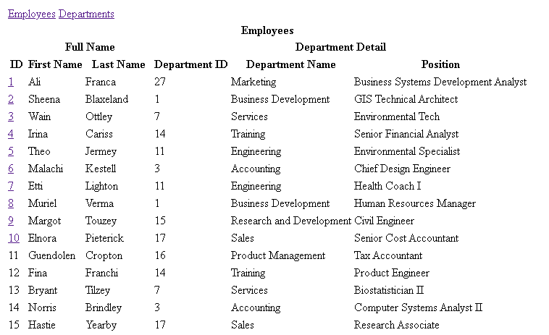

Figure Employees Page

Departments page provide us that each department detail. This page contains of department id and name fields.

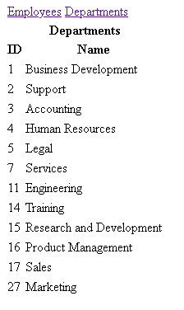

Figure Departments Page

Profile page give us more detail about employee. Such as email, phone, skills, and description.

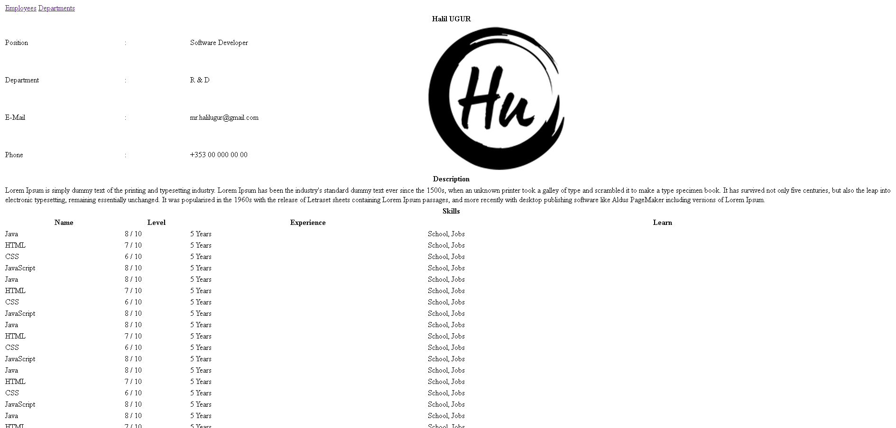

Figure Example Profile Page

This page provides that an employee’s salary history.

Figure Salary History Page

Job history page show that an employee’s old jobs.

Figure Job History Page

# Create CSS

We don't clear understand for each page to data. Because we don't have any mark that we say this title is important. Therefore, we need create CSS class and id for each page. We create a few CSS class for table attributes. Such as th, td, caption. Firstly, we did reset all CSS that apply by browsers. After that we prepared CSS file step by step. We added a few results page view below.

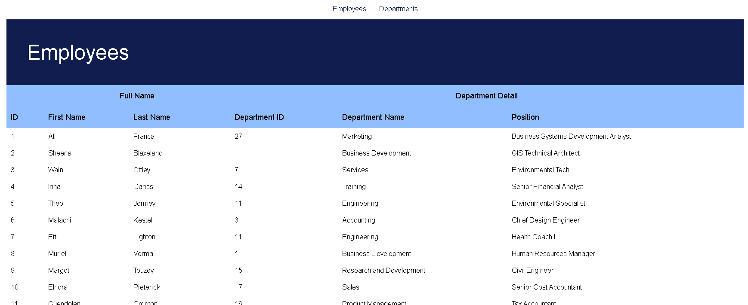

Figure Employees Page After CSS

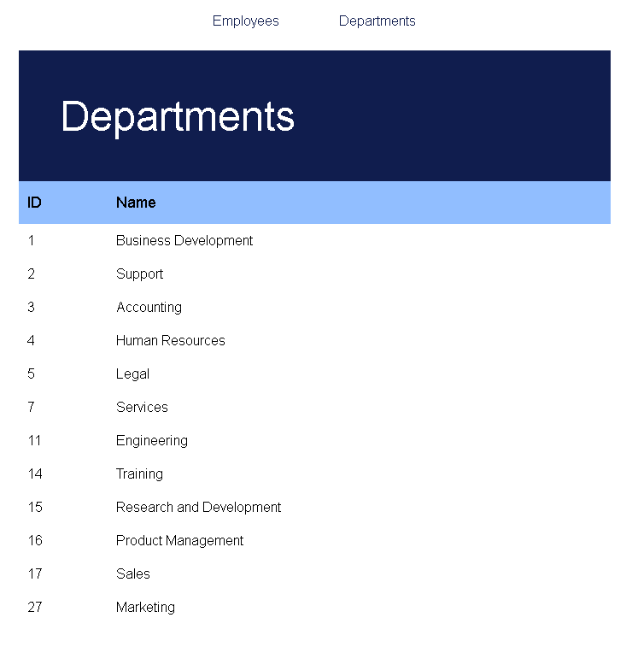

Figure Departments Page After CSS

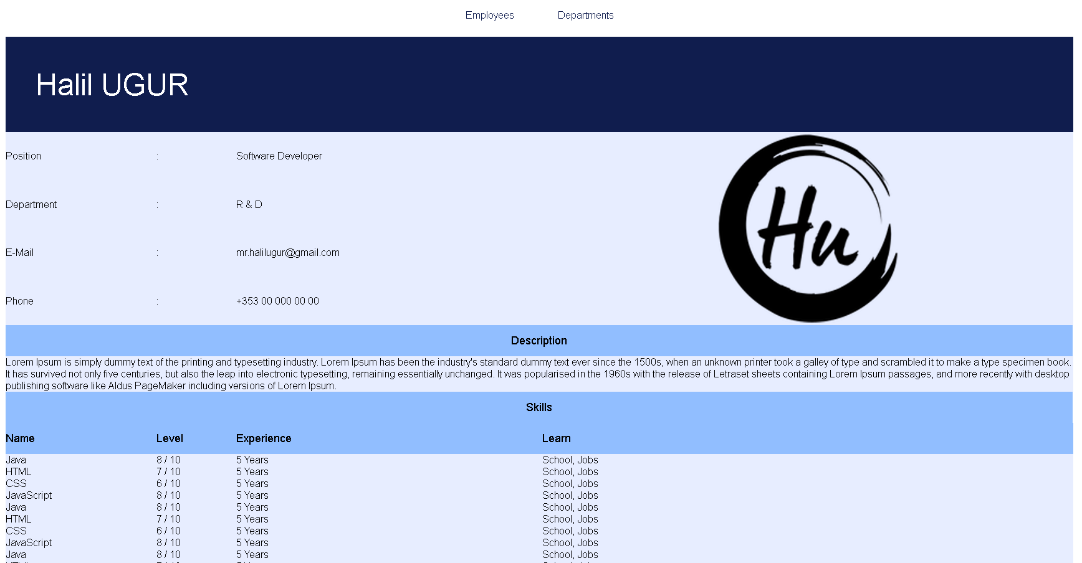

Figure Profile Page After CSS

# Final Touches

After creating the basic structure and applying the CSS structure, we added new features to make pages more understandable by making new arrangements.

**Zebra style**:

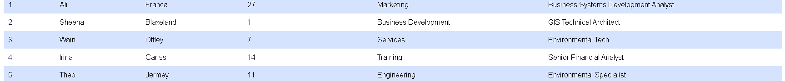

**Header of Tables**: Also, we added fixed header.



**Link Styles**:

**Employees Final Page**:

**Departments Final Page**:

**Profile Final Page**:

**Salary History Final Page**:

**Job History Final Page**:

# GitHub Repository

All the materials we use can be accessed from this repo: [GitHub Repo](https://github.com/halilugur/webdev_ca1)

# References

1. <https://www.w3schools.com/css/default.asp>
2. <https://www.w3schools.com/howto/default.asp>
3. <https://elad.medium.com/the-new-css-reset-53f41f13282e>
4. <https://www.w3.org/Style/Examples/011/firstcss.en.html>
5. <https://www.freecodecamp.org/news/html-tables-table-tutorial-with-css-example-code/>
6. <https://www.tutorialspoint.com/css/css_tables.htm>
7. <https://www.tutorialrepublic.com/css-tutorial/css-tables.php>